**Assignment 1(OOPJ)**

**Q1 http://sunsite.uakom.sk/sunworldonline/swol-07-1995/swol-07-java.html**

To make development a more platform-neutral process (and thus accommodate the consumer market's demand for CPU flexibility), Gosling began by extending the C++ compiler. however, he realized that even with lots of extras, C++ would not suffice. Thus, Oak was conceived in mid-1991. (The name came to Gosling when, while creating a directory for the new language, he glanced out his window, and spotted a tree. But the name didn't survive a trademark search, and was dropped in favour of Java.)By mid-1994, the World Wide Web was big.By early fall, Naughton and fellow Sun engineer Jonathan Payne finished writing WebRunner, a Web browser written using the Java language.

**Q2 https://javaalmanac.io/features/**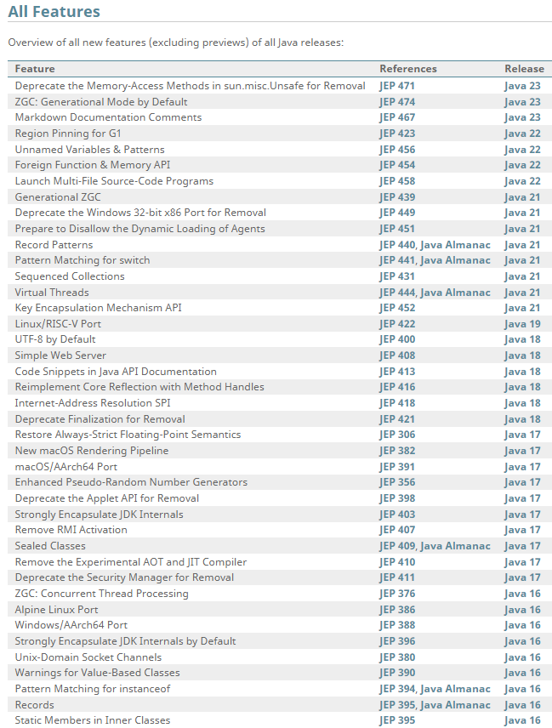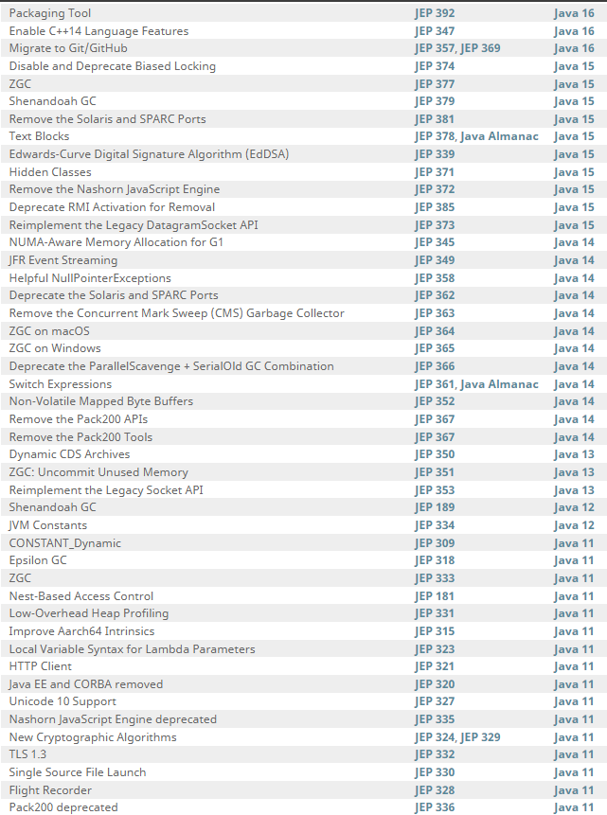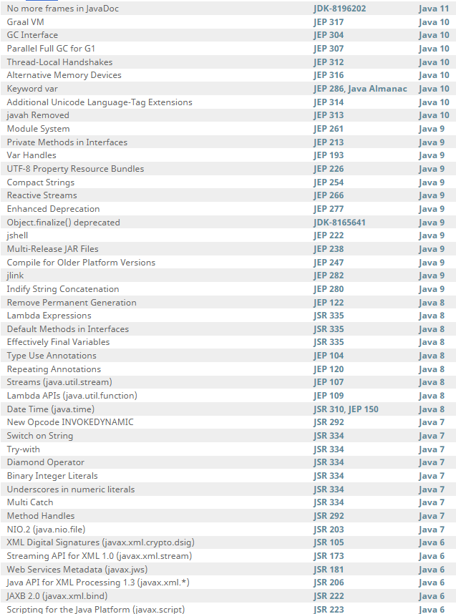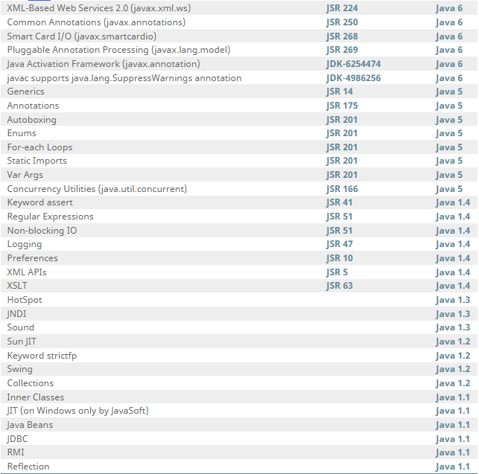

**Q3 https://whichjdk.com/**

To build and run Java applications, a Java Compiler, Java Runtime Libraries, and a Virtual Machine are required that implement the Java Platform, Standard Edition (“Java SE”) specification.

**Q4** [**https://docs.oracle.com/javase/8/docs/technotes/tools/windows/jdkfiles.html**](https://docs.oracle.com/javase/8/docs/technotes/tools/windows/jdkfiles.html)

Demos and samples that show you how to program for the Java platform are available as a separate download

Development Files and Directories describe the most important files and directories required to develop applications for the Java platform. Some of the directories that are not required include Java source code and C header files.

Additional Files and Directories describes the directory structure for Java source code, C header files, and other additional directories and files.

**Q5** [**https://docs.oracle.com/javase/tutorial/getStarted/intro/definition.html**](https://docs.oracle.com/javase/tutorial/getStarted/intro/definition.html)

The Java programming language is a high-level language that can be characterized by all of the following buzzwords:

Simple, object oriented, Distributed, Multithreaded, Dynamic, Architecture neutral, Portable, High performance, Robust, Secure

**Q6 Separate java file submitted**

**Q7** [**https://dzone.com/articles/jvm-architecture-explained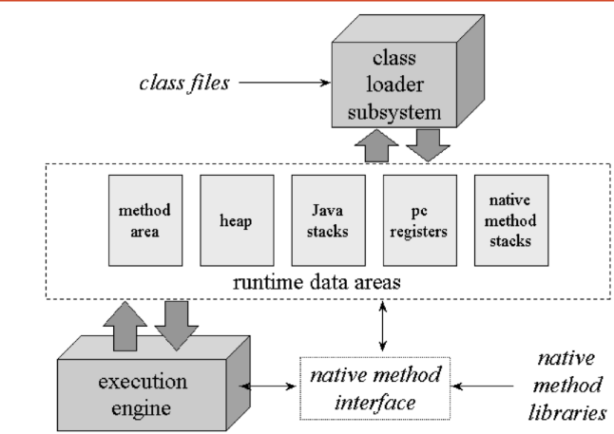**](https://dzone.com/articles/jvm-architecture-explained)

JVM is divided into three main subsystems:

1 ClassLoader Subsystem: Java's dynamic class loading functionality is handled by the ClassLoader subsystem. It loads, links. and initializes the class file when it refers to a class for the first time at runtime, not compile time. BootStrap ClassLoader, Extension ClassLoader, Application ClassLoader

2 Runtime Data Area: The Runtime Data Area is divided into five major components: Method Area, Heap area, Stack area, PC registers, native method stacks.

3 Execution Engine: The bytecode, which is assigned to the Runtime Data Area, will be executed by the Execution Engine. The Execution Engine reads the bytecode and executes it piece by piece.

Interpreter, JIT Compiler(Intermediate Code Generator, Code Optimizer ,Target Code Generator, Profiler), Garbage Collector, Native Method Libraries: